Whitewater Rafting Company Site Plan

# Company Logo

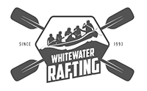

# Relevant Color Codes:

* primary-color: #878787
* secondary-color: #67785D
* accent1-color: #47222B
* accent2-color: A66C7E

# Typography:

* heading-font: Literata
  + <https://fonts.google.com/specimen/Literata?lang=en_Latn>
* Text-font: Gentium Plus
  + <https://fonts.google.com/specimen/Gentium+Plus?lang=en_Latn>

# Coolors URL

* https://coolors.co/878787-67785d-47222b-a66c7e